**ALTER** **TYPE** Adolescents_T

**ADD** MEMBER **FUNCTION**

calclDiscount **RETURN** FLOAT

**CASCADE;**

**/**

**ALTER** **TYPE** Adolescents_T

**ADD** MEMBER **FUNCTION**

taxPayment**(**RATE FLOAT**)** **RETURN** FLOAT

**CASCADE;**

**/**

**CREATE** **OR** **REPLACE** **TYPE** **BODY** Adolescents_T **AS**

MEMBER **FUNCTION** calclDiscount **RETURN** FLOAT **IS**

discount FLOAT**;**

**BEGIN**

**SELECT** **SUM(**0.02 **\*** SELF**.**paymentfee**)** **INTO** discount

**FROM** **TABLE(**SELF**.**Guardian**)** d

**WHERE** d**.**samurdhi **=** 'N'**;**

**RETURN** discount**;**

**END;**

MEMBER **FUNCTION** taxPayment**(**RATE FLOAT**)** **RETURN** FLOAT **IS**

**BEGIN**

**RETURN** SELF**.**paymentfee **\*** RATE**;**

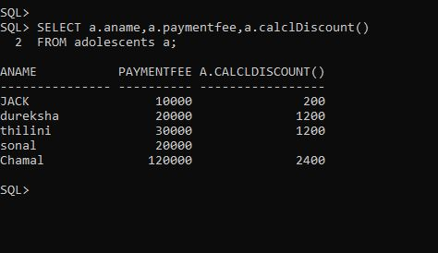 **END;**

**END;**

**/**

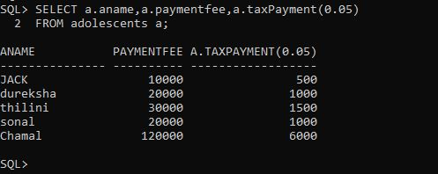

**ALTER** **TYPE** Doctor_t

**ADD** MEMBER **FUNCTION** aditionalOTcharge**(**rate FLOAT**,**othours FLOAT**)**

**RETURN** FLOAT **CASCADE;**

**/**

**ALTER** **TYPE** Doctor_t

**ADD** MEMBER **FUNCTION** TotalCharge_WithOT**(**rate FLOAT**,**othours FLOAT**)**

**RETURN** FLOAT **CASCADE;**

**/**

**CREATE** **OR** **REPLACE** **TYPE** **BODY** Doctor_t **AS**

MEMBER **FUNCTION**

aditionalOTcharge**(**rate FLOAT**,** othours FLOAT**)**

**RETURN** FLOAT **IS**

**BEGIN**

**return** rate**\*** othours **\*** SELF**.**visitChg**;**

**END** aditionalOTcharge**;**

MEMBER **FUNCTION**

TotalCharge_WithOT**(**rate FLOAT**,**othours FLOAT**)**

**RETURN** FLOAT **IS**

x float**;**

**BEGIN**

x **:=** rate **\*** othours **\***SELF**.**visitChg**;**

**RETURN** x**+**SELF**.**visitChg**;**

**END** TotalCharge_WithOT**;**

**END;**

